New Profile Picture:
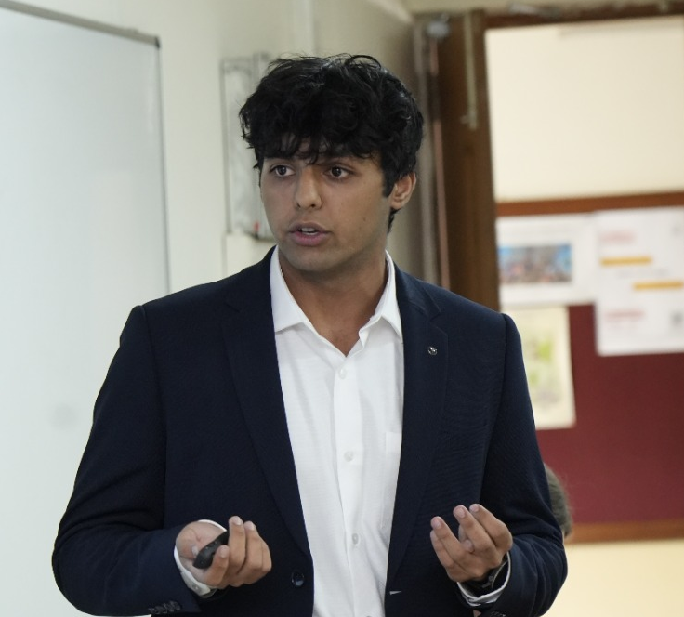
I’m Daksh, a 17-year-old from Bangalore, India, passionate about computational algorithms. My favourite question in the world is “How do I model something amid the chaos of a dynamical system?” At RSI at IISc, I'm chasing it properly by designing a mathematical tool to predict the moment a system tips into chaos. What hooked me is that chaos isn’t just noise: it has structure, and you can spot warning signs before systems fall apart. That same motivation drove me to create Persifolio to diagnose risk-taking ability in today's dynamic stock market and geopolitical landscape. Every position I take, whether it’s built on candlestick patterns, support and resistance, or the zig-zag method, is a small bet on a model of risk, reward and probability, and the market tests. Algorithms, for me, are a way to navigate uncertainty, whether I’m hunting for order in a chaotic system in a lab or reading structure in the swings of a chart on my screen.

Badminton Under 17 Boys Singles state semifinalist:
https://drive.google.com/file/d/1_cjRSCbgzq0cjSTzB4JbLyQOyJDCQSM2/view?usp=sharing

Hobbies and Passion:
Trading: Background Picture needs to be present not the background anymore. Make the background fit more in the theme of the website. The current background image should be present in the side saying: My trading strategy.

Badminton Under 17 Boys Singles state semifinalist:
https://drive.google.com/file/d/1_cjRSCbgzq0cjSTzB4JbLyQOyJDCQSM2/view?usp=sharing

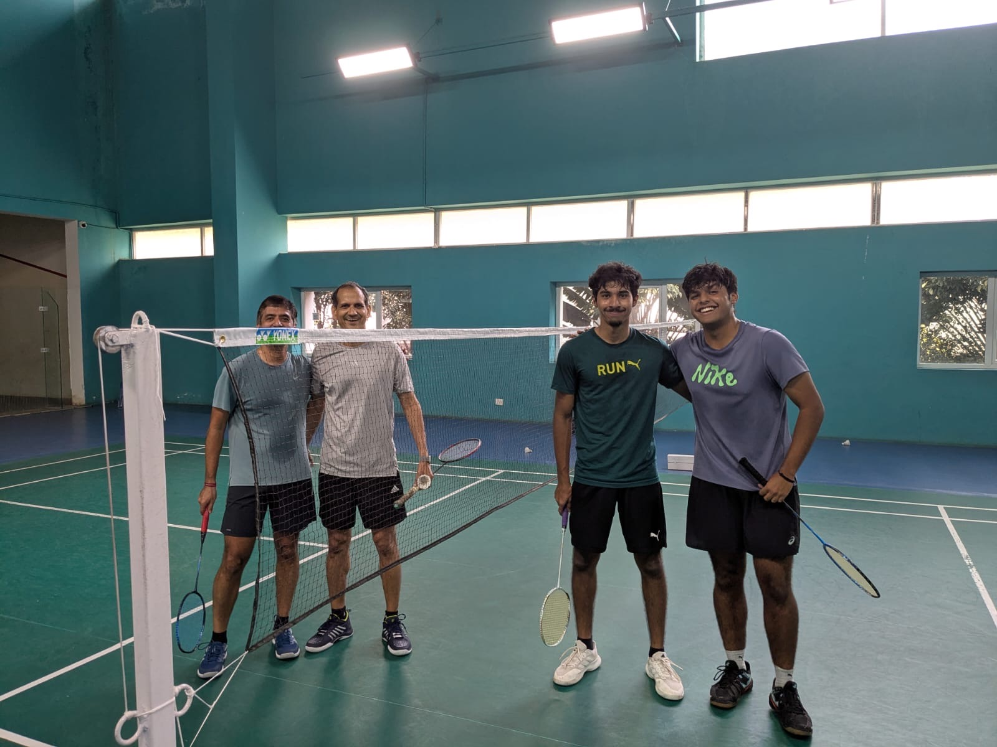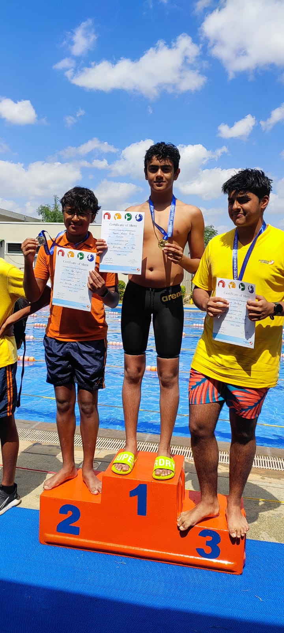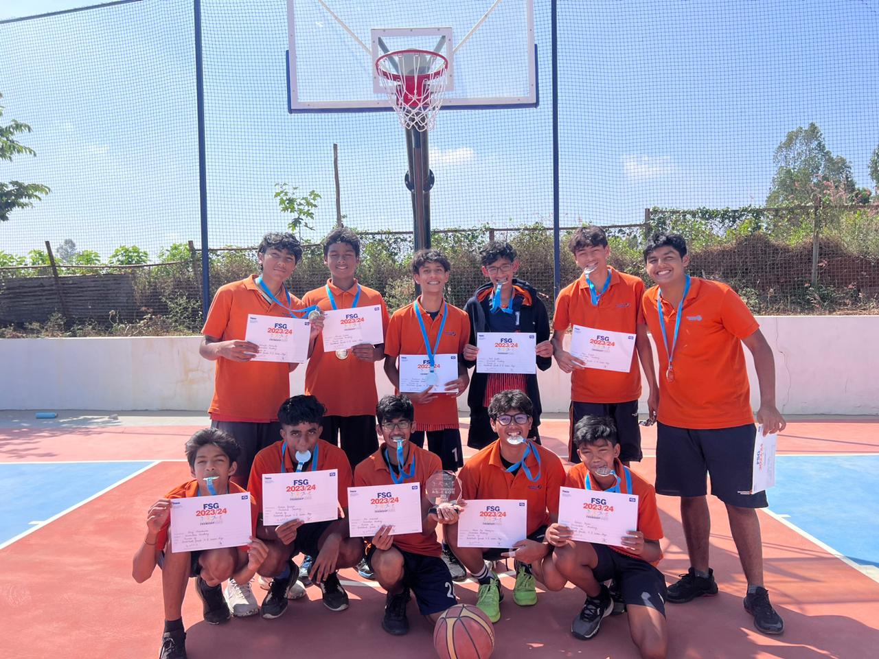

Inventure Academy Award of Excellence : TechWhiz | Recognised by the school as among the top two best coders in the whole grade
Inventure Academy Award of Excellence : Computer Science | Recognised by the school as being the grade topper in the subject of computer science
Inventure Academy Award of Excellence: Multiachiever award | Recognised by the school as the most well rounded student in the grade.
Portfolio Strategy Challenge -Winner, HDFC Credelia | Stock portfolio designed for a client and won First place in the investment pitch competition.
Inventure Academy Award of Excellence: Community Outreach Award | Recognised as the top two students with the best community outreach and show care for the communites around them

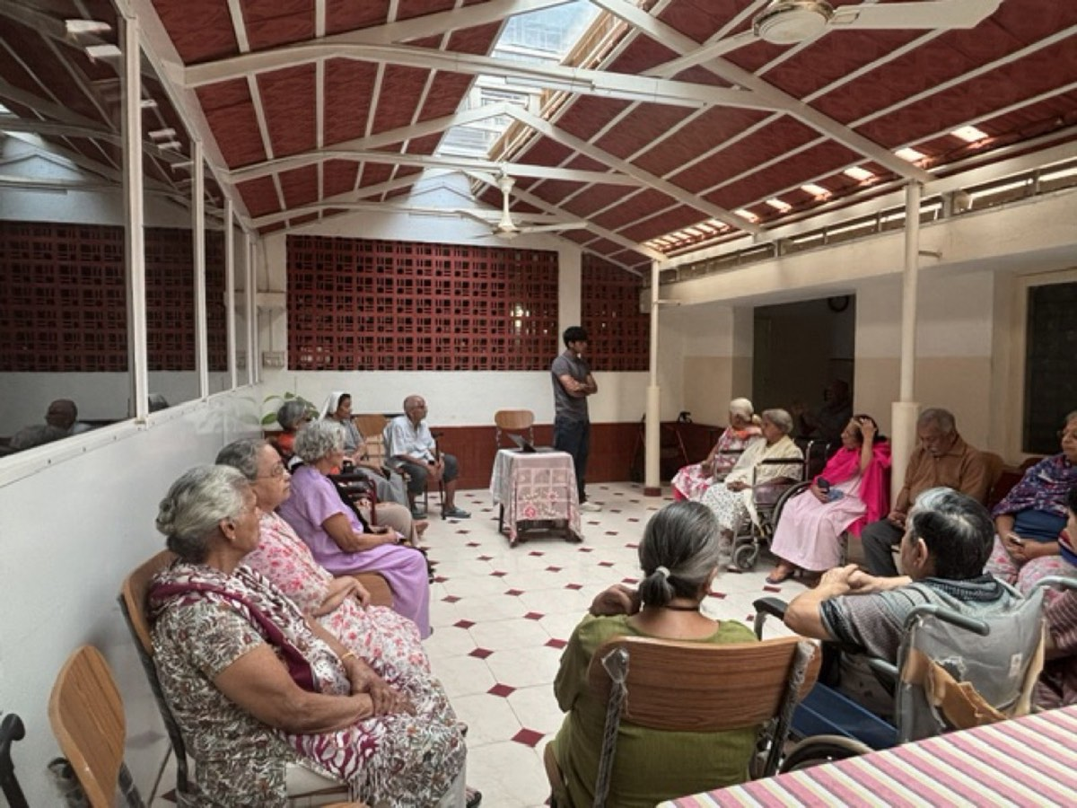
Scam Slayer Cover Picture
Article: https://www.outlookindia.com/xhub/featured-insights/teen-developer-daksh-sawhney-builds-scamslayer-fraud-detection-app-protecting-1000-senior-citizens-from-digital-scams
Description: Web-Based System for Experiential Fraud-Recognition Training Using Simulated Threat Scenarios for Vulnerable User Populations
Scam Slayer relates to a web-based system for experiential fraud-recognition training for vulnerable populations, particularly senior citizens. A scenario engine presents simulated threats, including phishing messages, impersonation attempts and fraudulent arrest notices, through an interactive browser interface. A response-evaluation module analyses user choices, identifies overlooked warning signs and provides corrective feedback on safer verification and reporting actions. A progress-tracking module records performance and measures improvements in fraud recognition across sessions. Based on recorded errors, the system selects subsequent scenarios featuring previously missed cues in different contexts, reinforcing practical recognition skills. Simulated payment and credential requests remain inoperative.

ADD this LOR: Government of Karnataka LOR: https://drive.google.com/file/d/1_1ORyucFaWquhrn9qrLyZ0sfBMXHCKfm/view?usp=sharing
Patent Published needs to be added in the timeline in the first landing page also.

Persifolio:
Cover Picture:
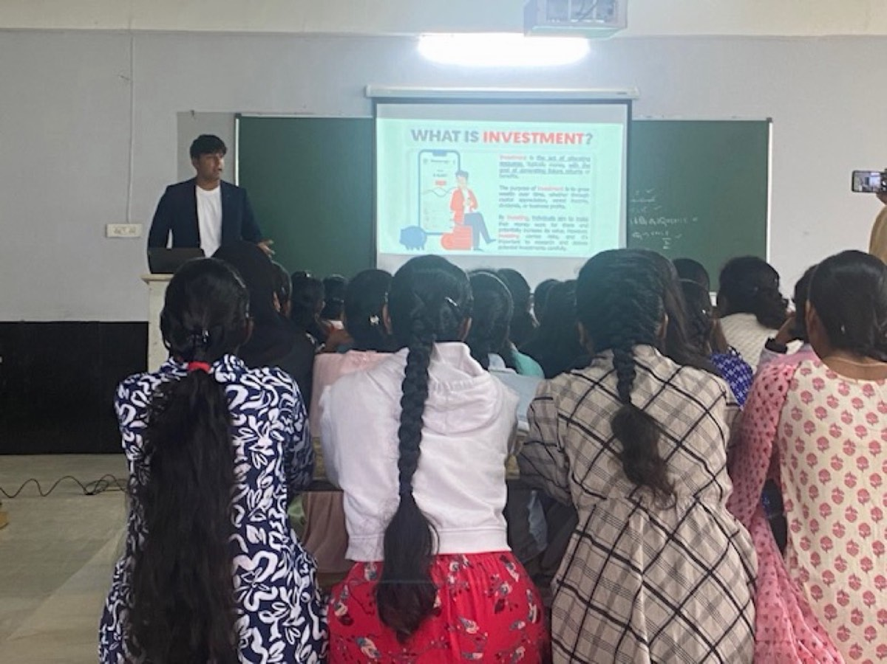
The product Images: Has a zip file: Change to this https://drive.google.com/drive/folders/1rj9KWKJbemy3yHc6fxm78pLY_Bx7al5W?usp=sharing
Remove LOR by MP
Remove Persifolio letter
Cover 3 statistics should be: 4000+ people reached, Patent Published, $50000 raised + $25000 Self funded from trading profit

Polaris:
ADD LOR:
https://drive.google.com/file/d/15OQqsNnKIWvXW0ROZoHGO5cKhPPAc7gA/view?usp=sharing

The tree plantation project should go above the MoneyBall Porject:

Needs to be changed to Project LOR.
Link to EcoWeave: https://miyawaki-monitor.ai.studio/

Research:
Research Science Institute:
Opening picture:
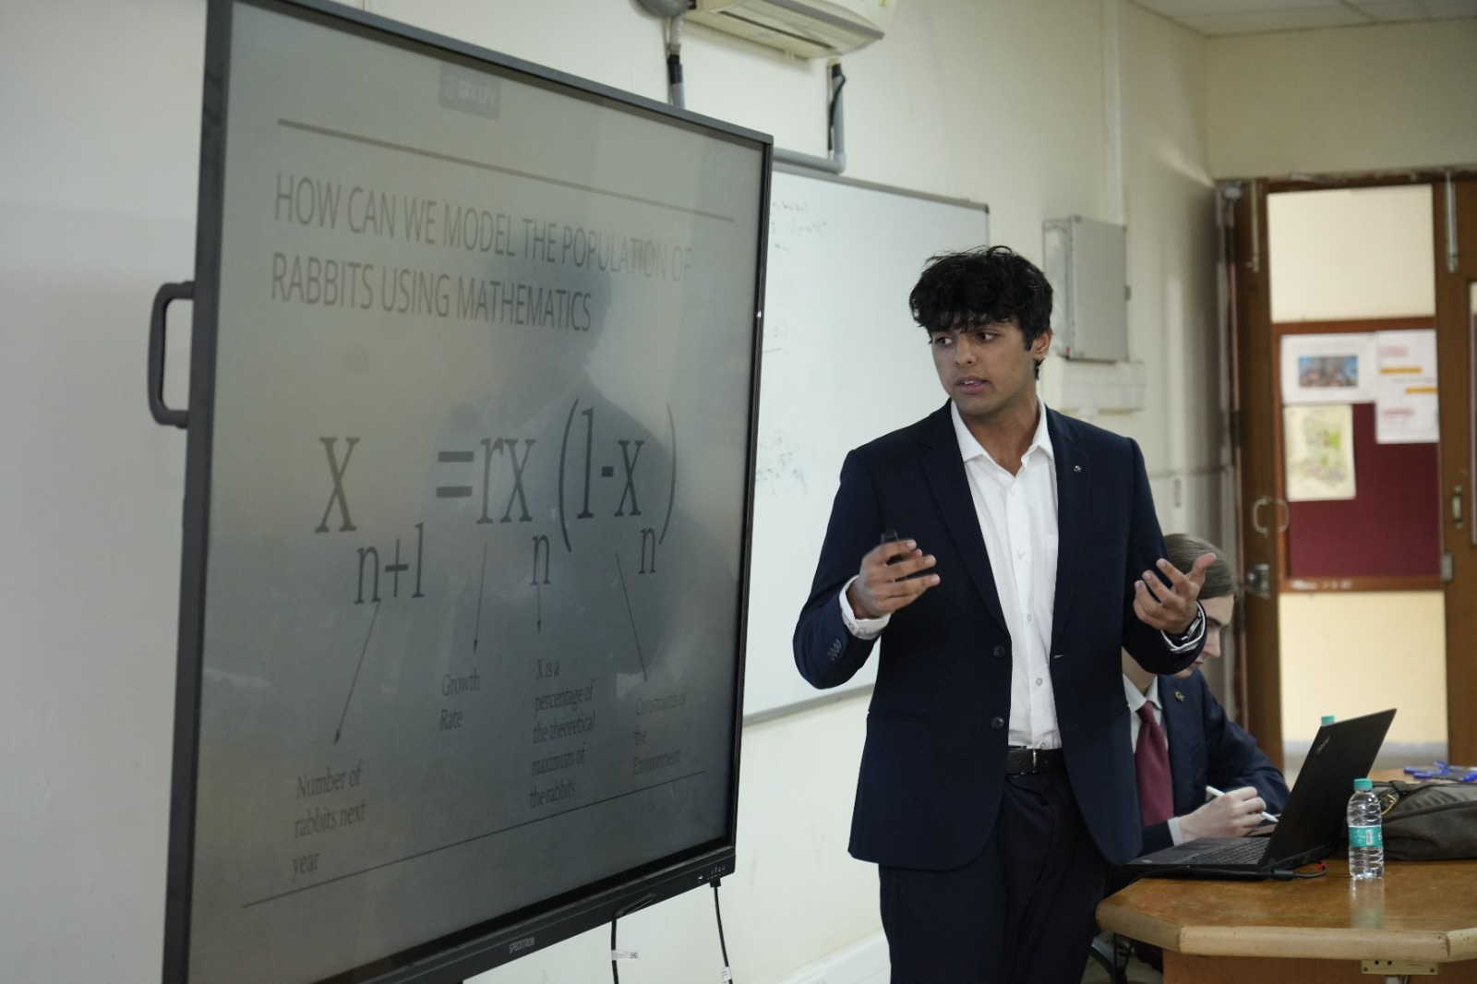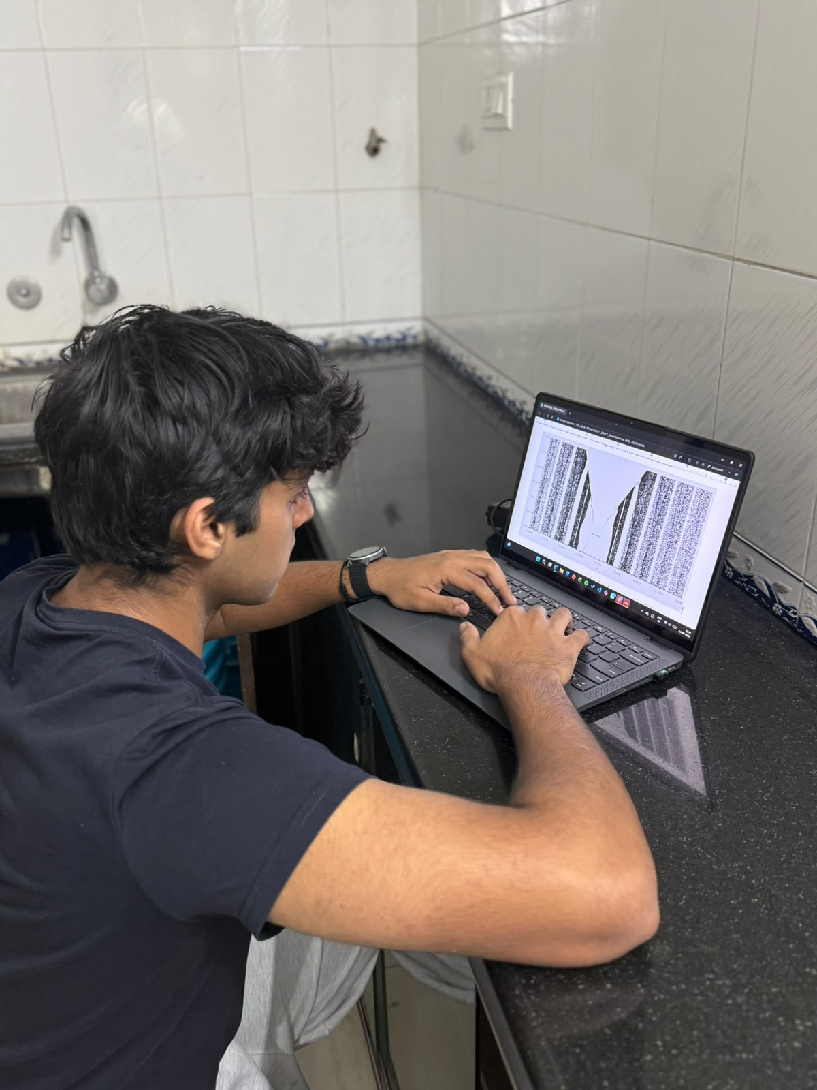
This picture should be added to the RSI image toggle

Overall less cluttering of the website UI.

